1-Grapheme

what is Grapheme
# Source: Chatgpt (GPT-4-turbo) at [7/21/2025]
A grapheme is the smallest unit of a writing system that represents a meaningful element of language. It’s the written equivalent of a phoneme (a sound in speech).

🧾 Definition:
# Source: Chatgpt (GPT-4-turbo) at [7/21/2025]
A grapheme is a symbol or group of symbols used to represent a sound (phoneme), syllable, word, or meaning in written language.

📝 Examples of Graphemes:

1. In Alphabetic Systems (like English):
# Source: Chatgpt (GPT-4-turbo) at [7/21/2025]
- A single letter is usually a grapheme:
  - b, t, a
- A combination of letters can also be one grapheme if it represents one sound:
  - sh in ship
  - ch in chat
  - th in this

2. In Syllabic Systems (like Japanese Kana):
# Source: Chatgpt (GPT-4-turbo) at [7/21/2025]
- Each kana character (like か, き, く) is a grapheme representing a whole syllable.

3. In Logographic Systems (like Chinese):
# Source: Chatgpt (GPT-4-turbo) at [7/21/2025]
- Each character (e.g., 山 = mountain) is a grapheme representing a word or morpheme.

🧠 Grapheme vs. Phoneme:
# Source: Chatgpt (GPT-4-turbo) at [7/21/2025]
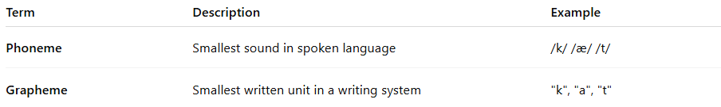

Term | Description | Example
Phoneme | Smallest sound in spoken language | /k/ /æ/ /t/
Grapheme | Smallest written unit in a writing system | "k", "a", "t"
In the word "cat":
- Phonemes: /k/ /æ/ /t/
- Graphemes: "c", "a", "t"

📚 Summary:
# Source: Chatgpt (GPT-4-turbo) at [7/21/2025]
A grapheme is the smallest functional unit in a writing system, such as a letter, character, or symbol, that represents a sound, syllable, or meaning depending on the type of writing system.

